

BAUCHI COORDINATING OFFICE, M &E FROM APRIL 2024 TO JANUARY 2025.
1st QUARTER REPORT
S/N | PROGRAM/PROJECT | OBJECTIVES | ACTIVITIES | RESPONSIBILITY | TARGET | KPI | OUTCOME | REMARK/COMMENT
 | Survey on two local government area, ZAKI, GAMAWA on ONIONS among the twenty local government area of bauchi state. | To captured some of the key procedures in each local government areas of the state. | Activities of local producers are captured, and specific period of the availability of the product. | T.I | 50 | More numbers of farmers and producers are captured in zaki and gamawa local government area of Bauchi state | Inadequate capital for most of the producers in each local government areas. | Government should encourage the processor/producers with farm input in other to burst their productions.
2. | Stakeholder, state committee on export promotion council, and Bauchi export clusters. | To harness export business and to prefer solutions to export business in other to penetrate international market. | To enable state coordinating office to carryout workshop/seminar within the state. To encourage potential exporters within the state to be active in export activities. | PD | 50 Stakeholder and 25 clusters heads put together to encourage potential exporters and promote non-oil activities within the state. | More cluster heads are formed within the 20 LGAs of the state. | Creating a good network between the stakeholders and clusters head within the state. | State committee on export should scale up there activities with clusters heads to encourage more participation of SMEs on export.
3. | Courtesy call visit with selected registered company on solid minerals | To established familiarities between NEPC and the selected companies. | Location and activities of the companies are known as well as some of the challenges encounter during production. | Trade information. | 10 companies within the state. | To ensure the activities of the companies within the state. | Poor allocation of funds | More cordial relationship between NEPC staffs and the companies within the state
4. | Production of Local Commodity Price List of Exportable Products of Bauchi Origin. | To identify exportable products in the state;  To provide timely, accurate and reliable prices of exportable products on monthly basis. | Monthly, accurate & reliable prices of exportable products in the State ascertained | PD | Registered & Potential Exporters;  MSME’s and members of the Business Community. | Exact prices of commodities are captured in must of senatorial zone of the state. | Local commodities prices were able to be captured in the three senatorial zone of bauchi state. | Government should encourage export activities by providing more funds to SMEs and processors for more agricultural commodities productions.
State Coordinator Name:……………………………………………………………
Signature:…………………………………………………………………………………..
Date:…………………………………………………………………………………………

 | 2nd quarter 2024 Report
S/N | PROGRAM/PROJECT | OBJECTIVES | ACTIVITIES | RESPONSIBILITY | TARGET | KPI | OUTCOME | REMARK/COMMENT
1. | Survey on two northern senatorial local government area, ZAKI, GAMAWA on hibiscus among the twenty local government area of bauchi state. | To captured some of the key procedures in each local government areas of the state. | Activities of local producers are captured, and specific period of the availability of the product. | Trade information | Zaki and Gamawa local government area | To know the numbers of producers in the two senatorial zone in bauchi state. | Inadequate capital for most of the producers in each local government areas. | Government should encourage the processor/producers with farm input in other to burst their productions.
2. | Meeting with state implementation committee on one state, one product [OSOP] | To discuss about the installation of sesame machine and the location. To always discuss the way forward with clusters heads. | To see the success of Cluster group in the twenty local government of the state. To also help in value addition of sesame in the state. | Trade information | Bauchi State | To ensure the installation of sesame seed machine. | Poor allocation of fund to the state implementation committee. | A cordial relationship between the state implementation committee, stakeholders and the council.
3. | 15th joint northeast domestic trade fair organize in bauchi state. | To provide avenue for domestic products with export potential in other to develop for export. To also provide avenue for indigenous exhibitors to showcase their products. | It pave way for the participation of other agency like NAFDAC, SON, NIGERIAN SHIPPER COUNCIL etc. | Trade information | The entire northeast are highly represented. | To display the comparative advantage of each state in the northeast. | Financial constraint that stop a lot of the indigenous to participant. Floatation of the change date of the trade fair. | More allocation should be given to the stakeholders to mobilize more participant for the trade fair. Publicity in terms of radio jingles, advertisement should be done.
4. | Production of Local Commodity Price List of Exportable Products of Bauchi Origin. | To identify exportable products in the state;  To provide timely, accurate and reliable prices of exportable products on monthly basis. | Weekly/Monthly, accurate & reliable prices of exportable products in the State ascertained | PD | Registered & Potential Exporters;  MSME’s and members of the Business Community. | Exact prices of commodities are captured in must of senatorial zone of the state. | Local commodities prices were able to be captured in the three senatorial zone of bauchi state. | Government should encourage export activities by providing more funds to SMEs and processors for more agricultural commodities productions.
State Coordinator Name:……………………………………………………………
Signature:…………………………………………………………………………………..
Date:…………………………………………………………………………………………

 |  | 3RD Quarter 2024 REPORT
S/N | PROGRAM/PROJECT | OBJECTIVES | ACTIVITIES | RESPONSIBILITY | TARGET | KPI | OUTCOME | REMARK/COMMENT.
1. | Meeting with state implementation committee on one state, one product [OSOP] | To discuss about the installation of sesame machine and the location. To always discuss the way forward with clusters heads. | To see the success of Cluster group in the twenty local government of the state. To also help in value addition of sesame in the state. | Trade information | 50 participants. | To enable the OSOP team improve the activities of export within Bauchi state. | Poor allocation of fund to the state implementation committee. | A cordial relationship between the state implementation committee, stakeholders and the council.
2. | One day Capacity building workshop on sesame seed at tafawabalewa local government | To enable the producer, processor of sesame added value to the products | To encourage the processor on value addition of the products | PD | 50 participants | Farmer, processor and merchant are able to know the fully agronomy practices of sesame seeds. | Increase in prices of farm input. Inadequate capital. | Government needs to have control over price.
3. | Production of Local Commodity Price List of Exportable Products of Bauchi Origin. | To identify exportable products in the state;  To provide timely, accurate and reliable prices of exportable products on monthly basis. | Weekly/Monthly, accurate & reliable prices of exportable products in the State ascertained | PD | Registered & Potential Exporters;  MSME’s and members of the Business Community. | Exact prices of commodities are captured in must of senatorial zone of the state. | Local commodities prices were able to be captured in the three senatorial zone of bauchi state. | Government should encourage export activities by providing more funds to SMEs and processors for more agricultural commodities productions.
State Coordinator Name:……………………………………………………………
Signature:…………………………………………………………………………………..
Date:…………………………………………………………………………………………

4th quarter 2024 report
S/N | PROGRAM/PROJECT | OBJECTIVES | ACTIVITIES | RESPONSIBILITY | TARGET | KPI | OUTCOME | REMARK/COMMENT
1. | Meeting with state implementation committee on one state, one product [OSOP] | To discuss the way forward of the state activities on export | To see the success of Cluster group in the twenty local government of the state. To also help in value addition of sesame in the state. | Trade information. | 50 participants present in the meeting. | To evaluate some major areas in the state that needs to be checked on informal trade | Poor allocation of fund to the state implementation committee. | A cordial relationship between the state implementation committee, stakeholders and the council.
2. | Production of Local Commodity Price List of Exportable Products of Bauchi Origin. | To identify exportable products in the state;  To provide timely, accurate and reliable prices of exportable products on monthly basis. | Weekly/Monthly, accurate & reliable prices of exportable products in the State ascertained | PD | Registered & Potential Exporters;  MSME’s and members of the Business Community. | Exact prices of commodities are captured in must of senatorial zone of the state. | Local commodities prices were able to be captured in the three senatorial zone of bauchi state. | Government should encourage export activities by providing more funds to SMEs and processors for more agricultural commodities productions.
3. | Second national conference on non-oil export | To showcase the activities of non-oil export to the public and the world at large. | More exportable products are showcase to the public and also NEPC double your export was elaborated to the public. | Trade information | Head office abuja | To show case the export potential of the country as well as double your export goal. | A lot of exporter complain on cost of transportation from different region. | There should be a support to the exporters to relief them from cost of transportation.
4. | Survey on informal trade in Bauchi state. | To captured important data base on products type, prices and final destination of the products. | To establish cordial relationship with the market official and NEPC | PD | Bauchi state | To capture data base of informal trade in the state | Poor knowledge of formal trade by most of the merchant. Poor government policy. | Formal education should made to the to merchant that are involve in the trade. There need for government to change their policy.
5. | End of the year retirement dinner | To celebrate active staffs that went for retirement in the council. | To celebrate the selfless services of the outgoing staffs in the council. | Trade information. | Head office abuja | To celebrate good virtues among staffs of the council | Inadequate funding for retirees | There should be a take up home packages for the retirees in form of cash appreciation.
State Coordinator Name:……………………………………………………………
Signature:…………………………………………………………………………………..
Date:…………………………………………………………………………………………

Below are the pictures of the project/ programs carryout in Bauchi Coordinating office from April 2024 to January 2025.

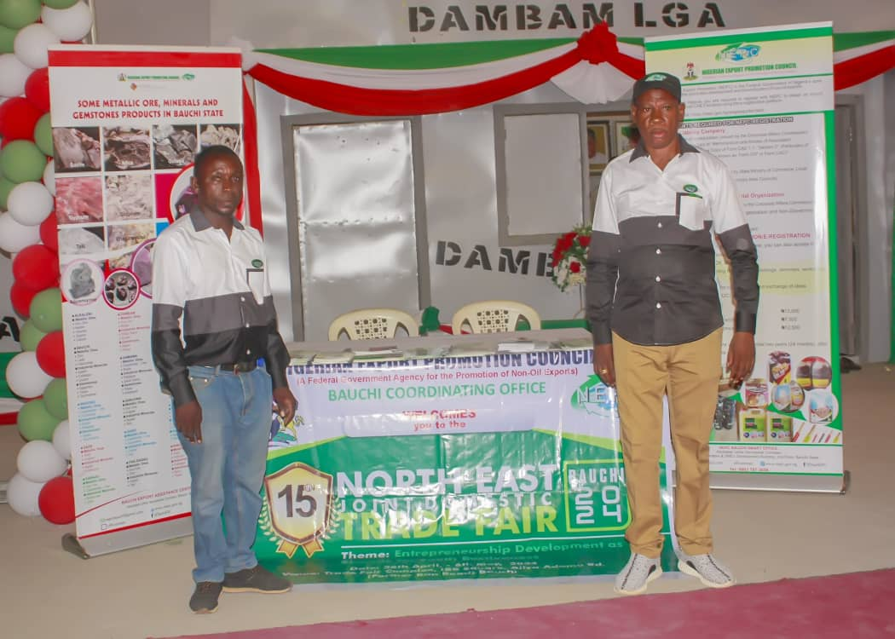
NEPC BAUCHI STATE COORDINATING OFFICE PARTICPATED AT THE FAIR PICTORIAL PRESENTATION From the right is the State Coordinator Mr Yakubu A. Ajagai & Mr Habila S. Musa

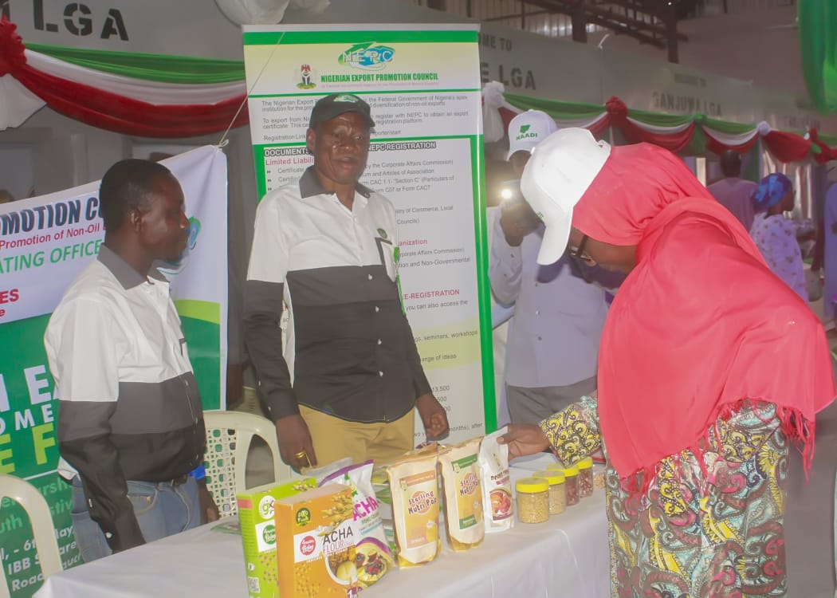
The Commissioner of women Affairs Hon Hajia Hajara Gidado of Bauchi State, Checking some of the exportable products displayed the table at NEPC Pavilion

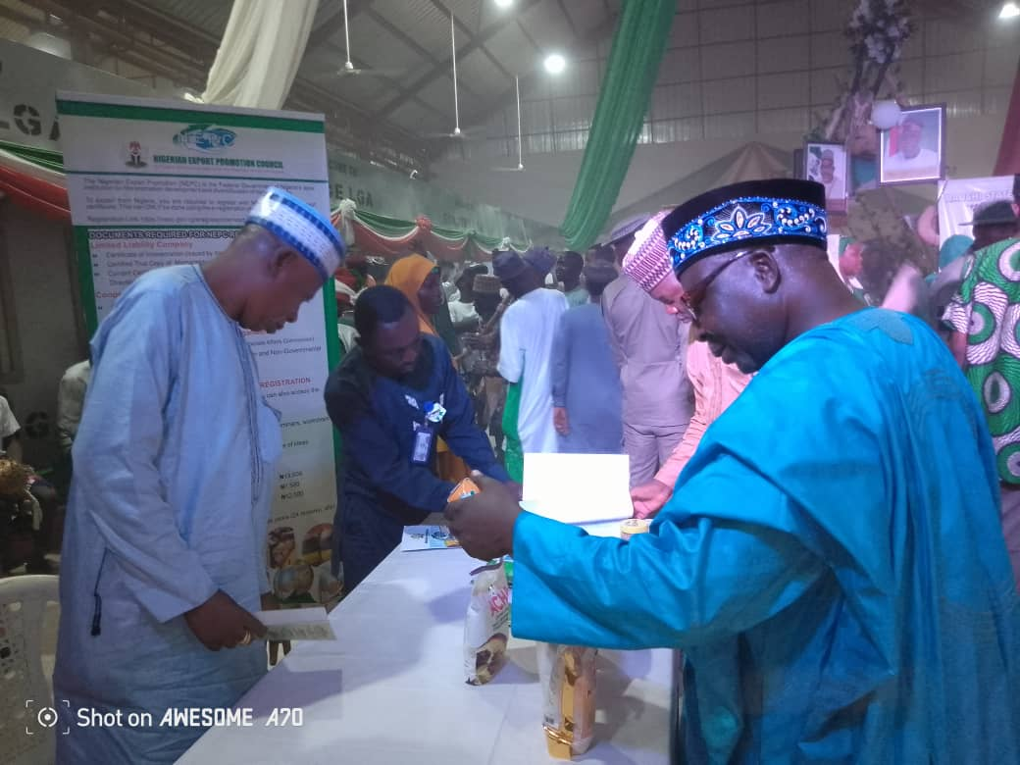
Bauchi State Commissioner of Agric Prof Simon Madugu Yalams at NEPC Stand Inspecting some of our publication during Bauchi Special Day making enquiry with him is the State Coordinator Mr. Yakubu A. Ajagai at the 15th Joint North-East Domestic Trade Fair at IBB Square 19th May, 2024.

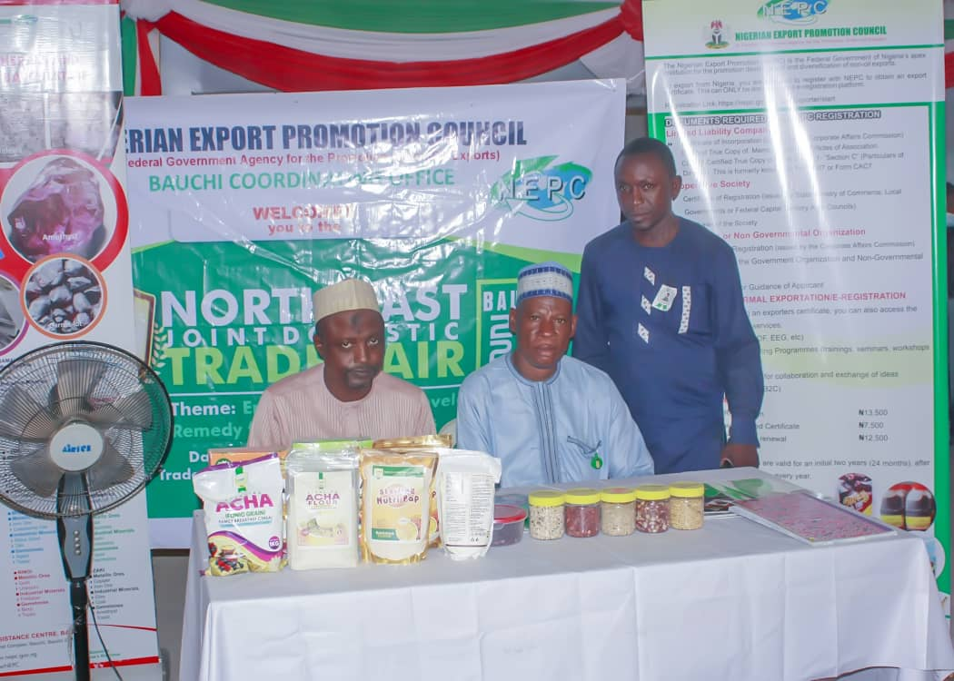
person Mal Ahijo Ahmed together with his counterpart Bauchi State Coordinator Mr. Yakubu A. Ajagai & Mr. Habila S. Musa during Bauchi special day. This are some of Agricultural products/process food products displayed at the just concluded 15th joint north-east domestic trade fair at IBB Square Bauchi.

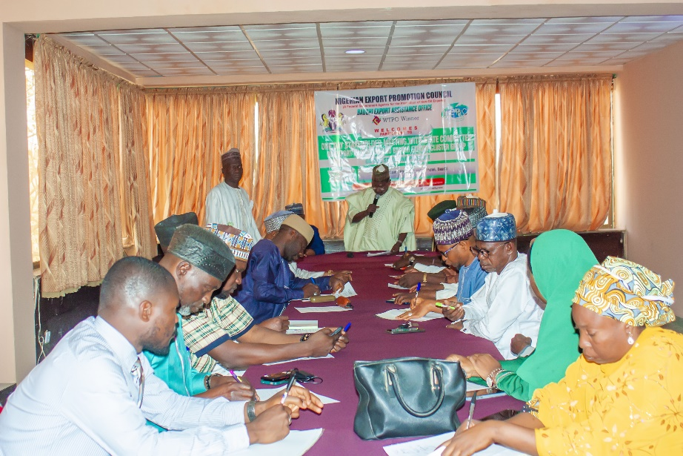
Meeting with the state committee on export at zaranda hotel Bauchi state.
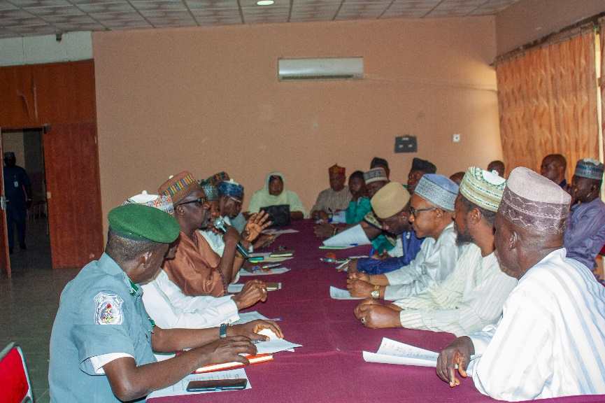
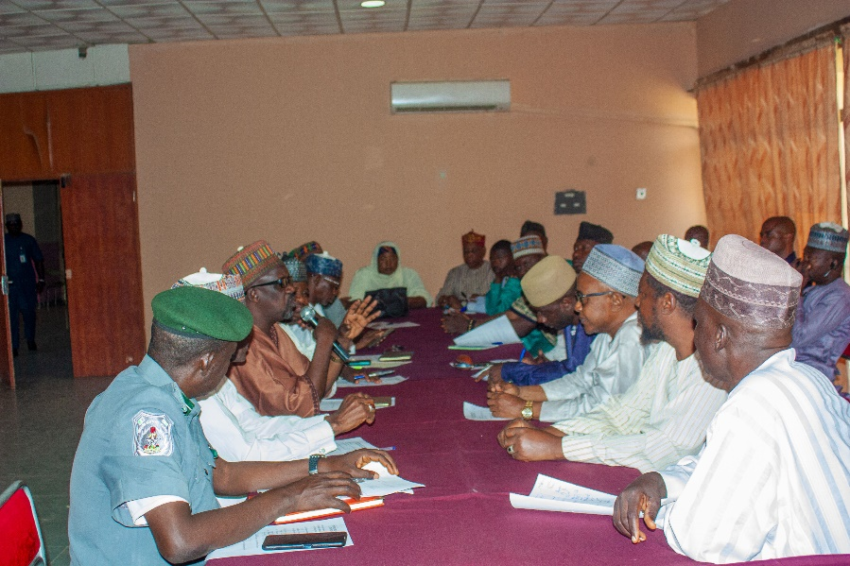
Stakeholder brainstorming on the way forward of the export activities within the state.

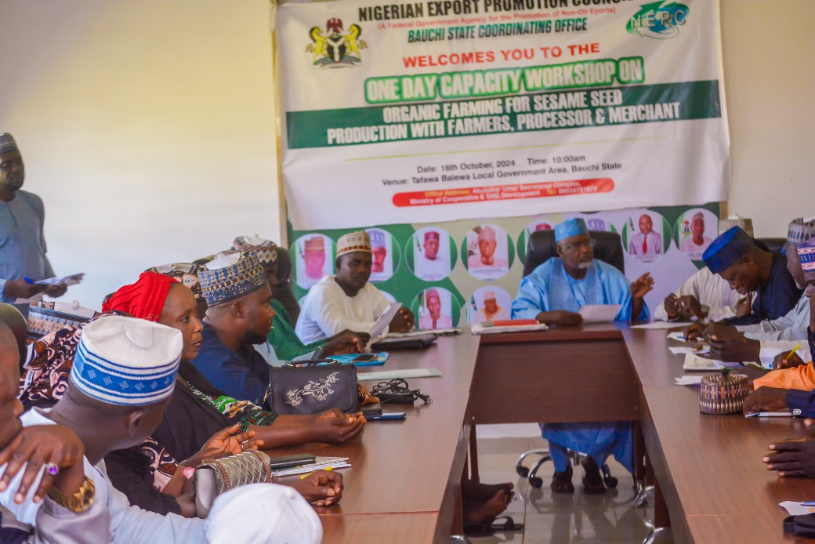
Capacity workshop on organic farming of sesame seeds at tafawabalewa local government area of Bauchi state.

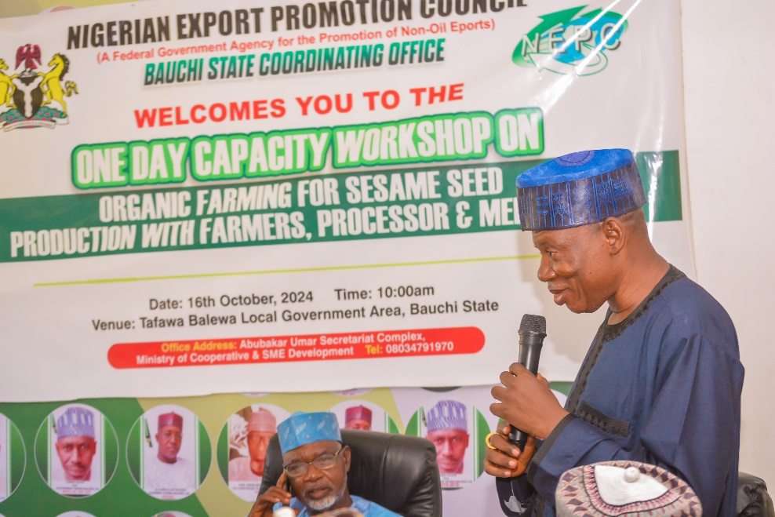
State Coordinator Mr yakubu Ajagai making his note address at the workshop in tafawabalewa local government area.
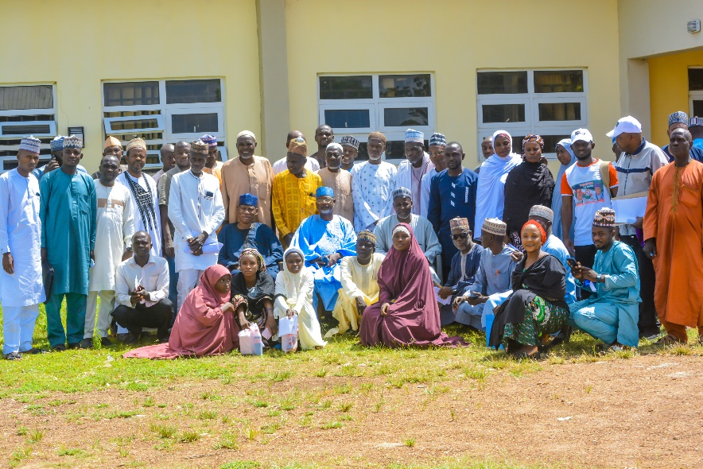
Participants at the workshop in tafawa balewa local government area of Bauchi state.

Border Market at ganda maiwa Ningi local government area of Bauchi state, where most activities of
Informal trade is carryout.
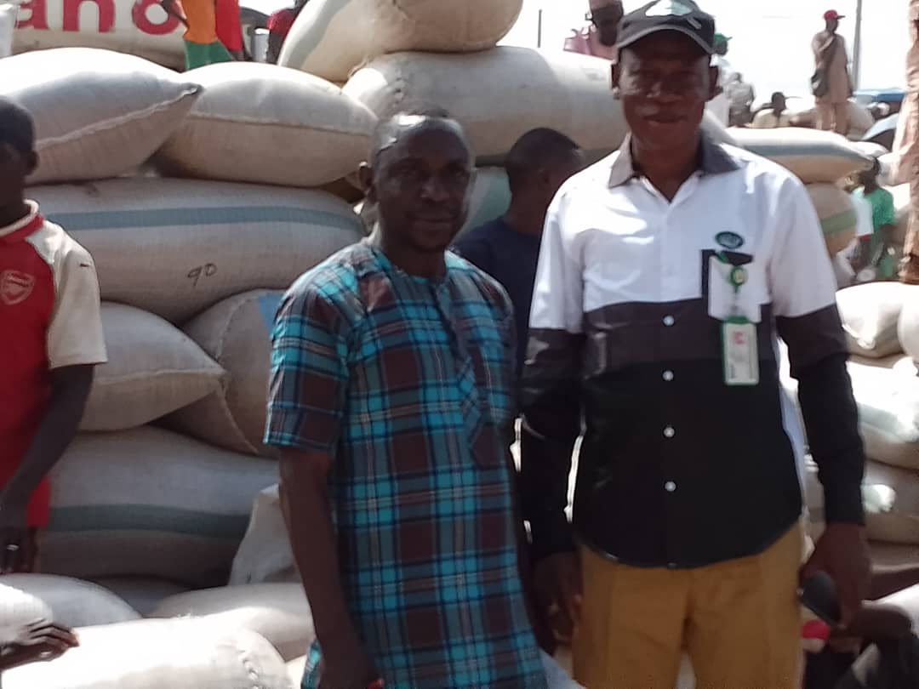
Spotted State Coordinator Mr Yakubu ajagai at ganda maiwa border market and Mr Habila musa,
To supervise the activities carryout in the market alongside market officials.
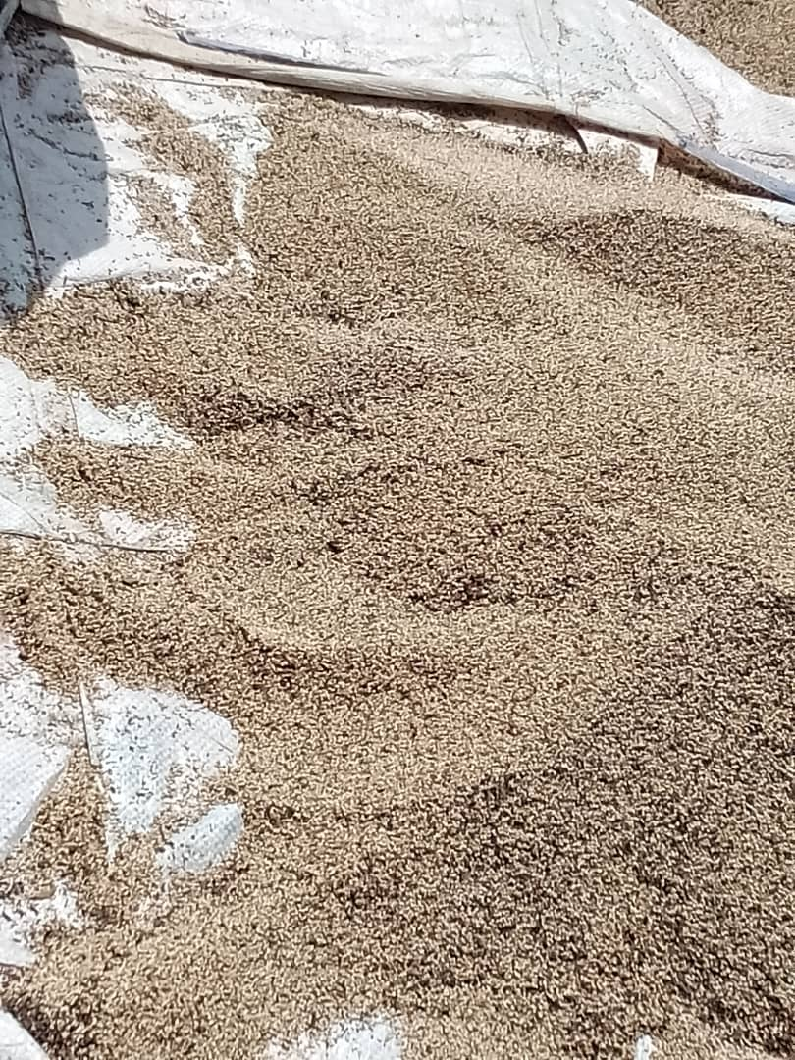
Pure sesame seeds display at the ganda maiwa market.

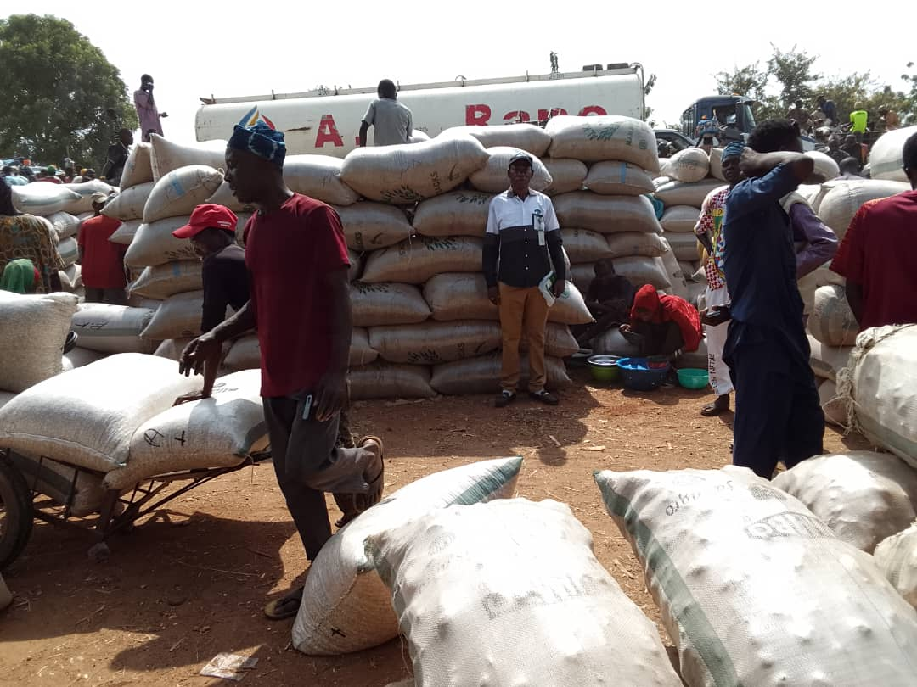
Maize, guinecorn, hibiscus flower, millet e.t.c all found in gadan maiwa market.

